Log Fundamentals - Lab Report

Date: 03/06/2026
Difficulty: Easy
Category: Defensive Security
Platform: TryHackMe

Overview

This lab goes over fundamental knowledge for logs and log analysis to find useful information when dealing with security incidents, troubleshooting or system incidents. I get hands on with Event Viewer to view logs and investigate an incident and I also look at manual log analysis on a Linux machine to find the information manually in the Apache access.log file.

2. Toolset Used

Tool | Purpose / Function
Event Viewer | Windows application used to view application, security and system logs and search for event ID’s to gather information

3. What I did

Logs are used to find attack traces on a system to see what might have happened and who might have done it. Logs can be used for many reasons such as security event monitoring, incident response and investigation/forensics, troubleshooting, performance monitoring and auditing/compliance. Logs are split into different categories based on the type of information they provide. Below are different log types and how they are used.

- System logs: Helpful to troubleshoot issues running in the OS and they provide information on various OS activities such as hardware events or driver loading events
- Security logs: Helpful for detecting and investigating incidents as they provide information on security activities such as authentication/authorization events and security policy changes
- Application logs: Contain specific events related to the application such as user interaction, application changes, updates or error events
- Audit logs: Contain information on system changes and user events which are helpful for compliance and security monitoring such as user activity or system changes
- Network logs: Contain information on the networks outgoing and incoming traffic which are useful in troubleshooting network issues and incident investigations such as network connection logs or network firewall logs
- Access logs: Provide information about access to different resources such as webserver access, database access and application access logs

Log analysis is used to extract important data from logs as it involves looking for any signs of abnormal or suspicious activity. Windows has a built-in application to view them – Event Viewer. This is a GUI which can be used to search for anything within the logs. In event viewer, the different types of logs can be seen on the left-hand panel which has sub-logs such as application, security and system logs. The middle panel shows the logs and the right-hand side panel gives options for analysing the logs.

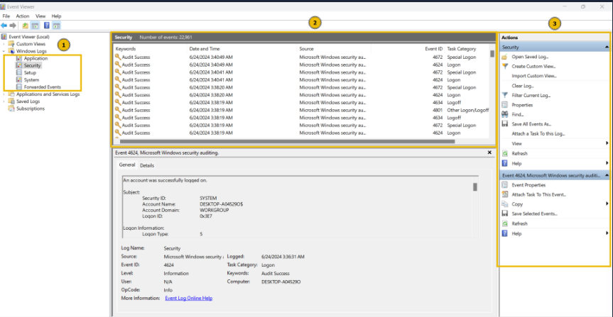

To view a specific log, double click on it and a pop up box appears with more details. It has different fields such as description, log name, logged (time of activity) and event ID (unique). The event ID’s can be used to search for a specific log. There are some important event ID’s which have been listed below.

- 4624: A user account has successfully logged in
- 4625: A user account failed to login
- 4634: A user account successfully logged off
- 4720: A user account was created
- 4724: An attempt was made to reset an account’s password
- 4722: A user account was enabled

- 4725: A user account was disabled
- 4726: A user account was deleted

Practical – Windows Event Viewer

This practical involves finding the activities of an attacker in the compromised system before they took access of the file server. To start, I opened Event Viewer and selected Windows logs > Security which showed all the security logs. Next, I wanted to find out the last user account to be created so I done Filter current log > event ID = 4720 and it returned 3 logs.

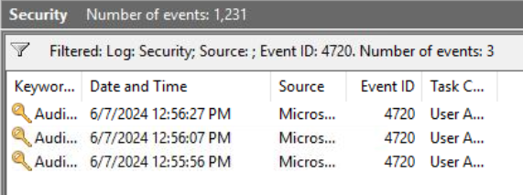

The first log was the most recent and when I clicked on it, I found that the user account created was named “hacked”. It was created by the administrator account on the 7th of June 2024.

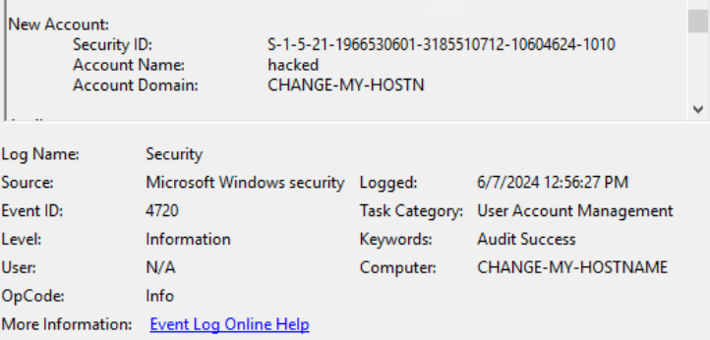

Web servers have their own logs to log requests made by users such as logins or uploads. You can find information such as timeframe, IP’s, request type, status code and URL. Apache web server access logs can be found in /var/log/apache2/access.log. Manual log analysis can be used in the command line on Linux by using “cat” to view the log files and manually read through them. The “grep” command can be used to search for strings and patterns in a log file such as searching for an IP (grep “192.168.1.1” access.log). The “less” command can be used to handle multiple log files and it lets you view one page at a time.

Practical – Manual Log analysis

On Linux, the access.log file is found and will be used to analyse logs manually. To find the IP which made the last GET request to the URL “/contact”, I used the grep command to search for this URL in the access.log file as shown below. It shows that the IP was 10.0.0.1.

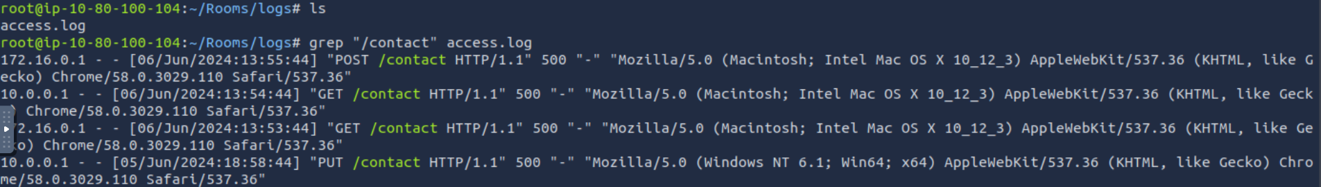

I then used the grep command again to search for the IP 172.16.0.1 and find out when the most recent POST request they made was which returned the 6th of June 2024. This matches to the /contact URL so the POST request was made to /command.

4. What I’ve learned

- How logs are used
- Types of logs
- Information available within logs
- Event ID codes and what they mean
- Using Event Viewer to automate log analysis
- Using commands such as grep and cat to view logs manually
- It’s important to use both automated and manual analysis

